How does rock structure and geology affect coastal landforms?

Geology affects the structure of coasts a lot:

* hard rocks like granite stick out as headlands
* soft rocks like sandstone and clay form bays

This is because hard rocks are more resistant to weathering and erosion than soft rocks

Concordant coastlines have rock types parallel to the coastline

Discordant coastlines have rock types perpendicular to the coastline

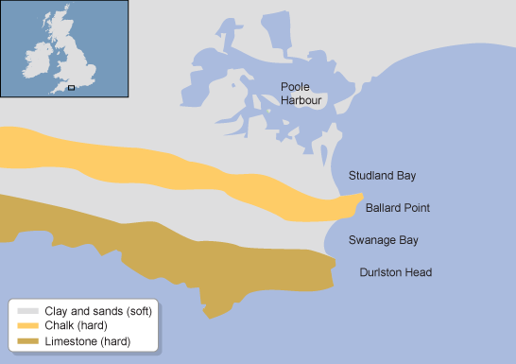

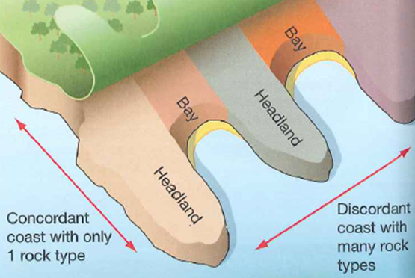

Anticline and syncline

An anticline is an upward fold

A syncline is a downward fold

The shape of the folds affects the coastal landforms

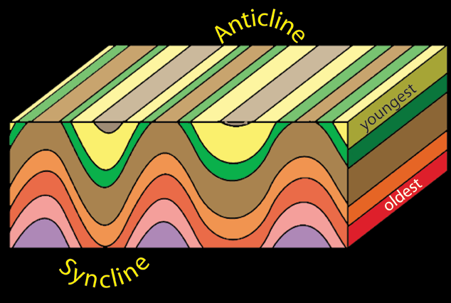

Coastal landforms: headlands and bays

Headlands

A headland is a cliff that juts out into the sea and is surrounded by sea on 3 sides. It is composed by hard rock such as granite, limestone or chalk. This is an erosional landform

Characteristics

* Near vertical cliff face
* High energy area with destructive waves
* Land rising steeply behind the cliff
* Juts out into the sea

Bays

A bay is crescent-shaped indentation in the coastline found between 2 headlands. It usually has a beach. This is a depositional landform

Characteristics

* Soft rock such as clay forming a crescent shaped beach
* Low energy constructive waves
* Two headlands mark the edges of the bay

How are headlands and bays formed?

For headlands and bays to form, there must be a discordant coastline. This means that the different types of rock are perpendicular to the sea. The different hardness of rocks means that they erode at different rates. The soft rock erodes to form bays and the hard rock doesn’t erode as much to from headlands.

In the later stages of development, the processes reverse. The sheltered bays become low energy environments in which deposition occurs, and the exposed headlands now become a target for erosion. This is explained by wave refraction

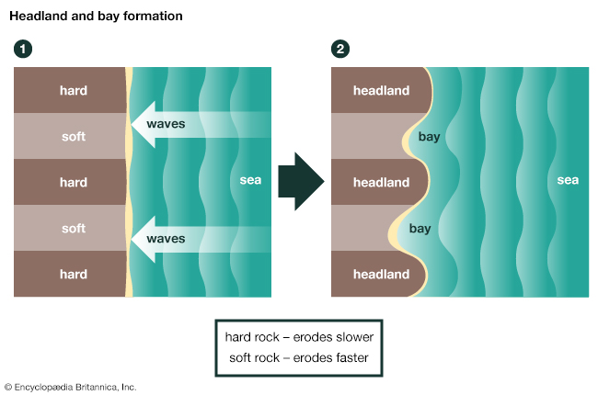

Wave refraction

* As the wave approaches the discordant coastline, it begins to take the shape of the coastline
* The part of the wave crest that is on course to break at the headland is the first to experience shallow water and to experience frictional drag. This slows down the lower part of the wave and makes it higher and steeper
* On either side of the headland, the faster parts of the wave now refract (bend) towards the headland to keep the line of the crest intact. This concentrates more wave energy on the headland. As a result, the rate of erosion is increased

